[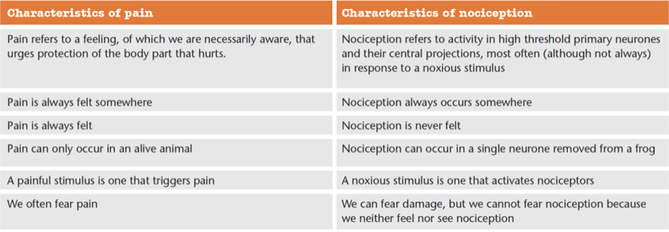](https://noigroup.cmail20.com/t/j-l-xkydyit-yhtttdjldl-j/)